Solar Photovoltaic (PV) System Permitting Checklist

The pre-submittal checklist below contains the minimum information and project plan details required to be submitted to the City of Gresham when applying for a permit to install a residential and commercial solar photovoltaic (PV) system. The intent of using the checklist is to provide transparent and well-defined information to minimize the number of required revisions, improve permit application quality, and accelerate the application and review process. In Gresham, solar companies typically manage permitting procedures, so this checklist is designed for their use.

Code and design criteria
The City of Gresham adopted the following codes pertaining to solar installations. Please visit the appropriate sections at these links for details. These sections can include electrical, design criteria, etc.

- Oregon Structural Specialty Code and Oregon Electrical Special Code:
https://www.oregon.gov/bcd/codes-stand/Pages/adopted-codes.aspx

- For a prescriptive rooftop system, you can complete the state document along with providing drawings: https://www.oregon.gov/bcd/Formslibrary/5952.pdf

- For design criteria based on location an applicant should go to the Oregon design criteria hub and search for the project address: https://oregon-explorer.apps.geocortex.com/webviewer/?app=6244abbf93e54b88a13a17b6cb6b9b37

- The state has provided a technical bulletin about how to achieve the required pathways in the building code: https://www.oregon.gov/bcd/codes-stand/Documents/techb-solarpv-pathways.pdf

- Installations that meet the definition of a ‘Small Solar Energy System’ may cover no more than 60% of the area of the roof on which they are located. See GCDC 10.0910 for more information. This applies to most of the solar installations located on homes.

Permitting process
A permit must be obtained prior to the start of any work. Complete the following permit application form(s) and submit any additional required documents.

Permits for solar installations are completed through the City of Gresham online portal:
https://greshamor-energovweb.tylerhost.net/apps/SelfService#/applicationAssistant?sectionName=Trending&showTemplates=false

Type the word ‘renewable’ into the search box located beneath ‘Application Assistant’ and it will bring up the options of ‘Commercial Renewable Energy’ and ‘Residential Renewable Energy’. Click the one that applies to your project.

Select the blue ‘Apply’ button on the right to begin the application process. The system will then guide the applicant through the process step by step. Different information will be requested at each step, such as the project location, a description of the project, and other required details.

During the ‘Attachments’ step, you will need to upload PDF documents including the following:

- Permit Application (use the Residential form or the Commercial form depending on your project)
- Site Plan
  - Site plan should show the location of major components on the property.
- Solar layout (with pathways shown)
- Electrical diagrams
  - Electrical diagram/worksheets should show PV and energy storage system configuration, wiring system, overcurrent protection, inverter, disconnects, required signs, and AC connection to the building.
- Equipment specification sheets
  - Provide spec sheets and manuals for all manufactured components including, but not limited to - PV modules, inverter(s), combiner box, disconnects, and mounting system
- Engineer letter or prescriptive document

Once submitted online, the application will begin processing and an invoice for the amount due will be issued. After payment is received, the application review can begin. Permit fees vary depending on system size and can be calculated using the table below and are calculated as part of the permit application.
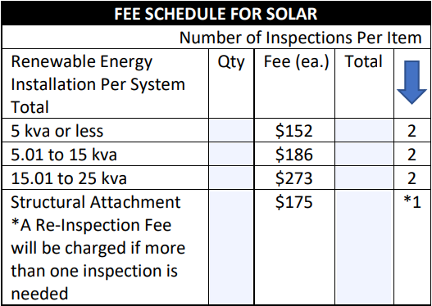

It takes about 14 days for the City to provide first comments. If revisions are required, the applicant will be notified and given a spot to upload corrections online. After the applicant submits corrections, re-review takes about 14 days.

When the review is complete, the applicant will receive an email with a link to the issued permit. The applicant will need to print a copy of the approved, stamped plans and have them onsite for the inspection. At that point work can start on the project.

Once the project has been completed, inspections can be scheduled through the online portal. Solar projects only require one inspection: a ‘Renewable Energy Final’ to close out the permit process. Note that once a permit is issued, it’s expected the project moves forward at a reasonable pace.

Reach out to our Permit Center with any questions about this process:
PermitCenter@GreshamOregon.gov | 503-618-2845

